TC-VER-010
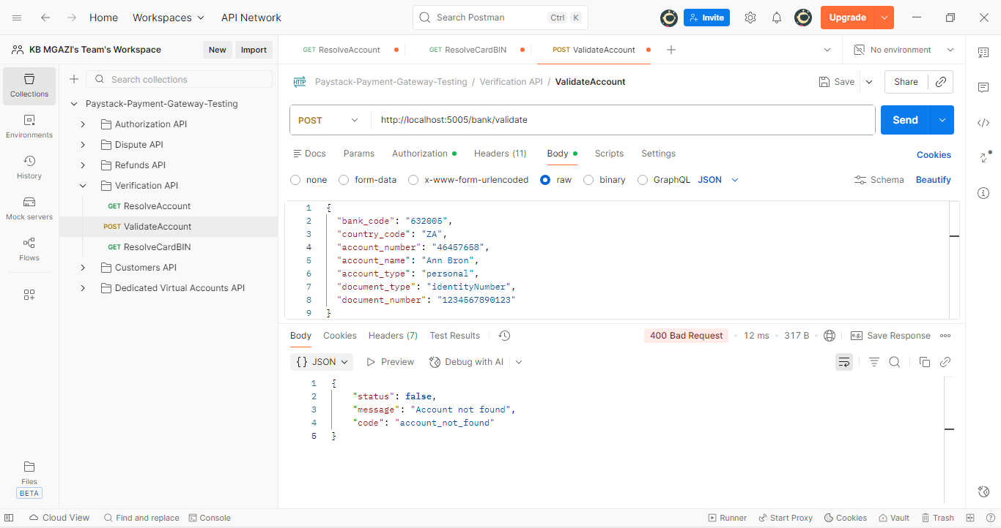
Request:
{
"bank_code": "632005",
"country_code": "ZA",
"account_number": "46457658",
"account_name": "Ann Bron",
"account_type": "personal",
"document_type": "identityNumber",
"document_number": "1234567890123"
}

Response:
{
"status": false,
"message": "Account not found",
"code": "account_not_found"
}

